**Deep Learning**

* There are total 5 Parts of Deep Learning :-

ANN

CNN

RNN

Autoencoders and GAN

Object Detection and image Segmentation

1. **ANN**

* ANN is stand for artificial neural network.

**🧠 What is a Perceptron?**

* The **perceptron** is the **simplest type of artificial neural network**, and it was one of the first algorithms proposed for supervised learning of binary classifiers.
* It was invented in 1958 by **Frank Rosenblatt** and is the **building block** for more complex neural networks used in deep learning today.

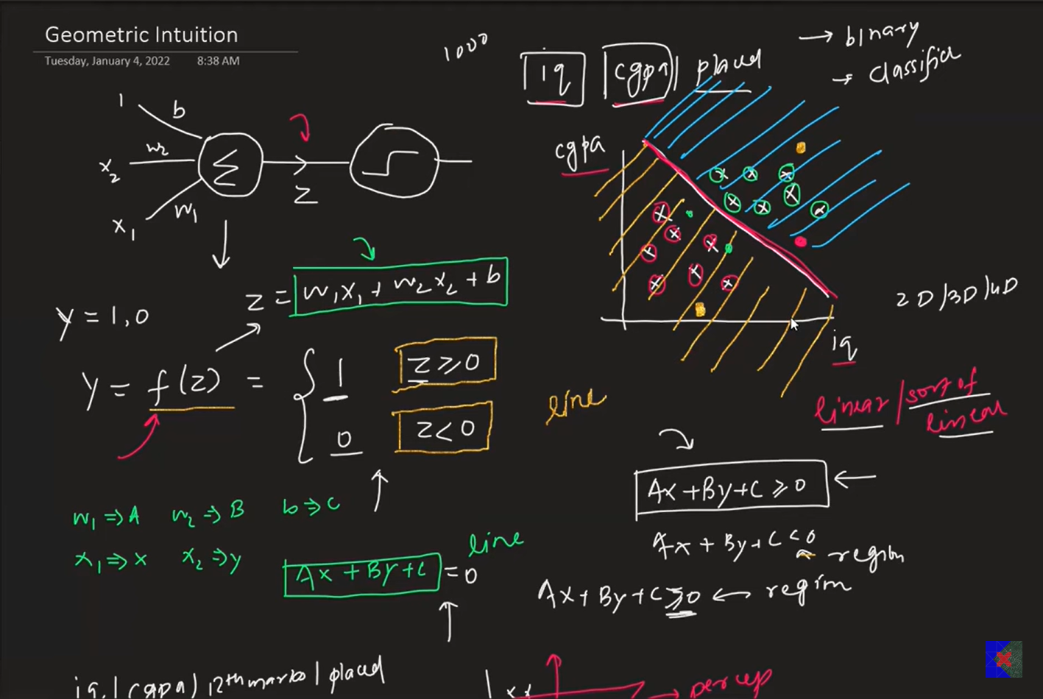

**Step-by-step Flow:**

1. **Inputs:**  
   Multiple numerical values (features), e.g., [x₁, x₂, x₃].
2. **Weights:**  
   Each input is multiplied by a weight [w₁, w₂, w₃].
3. **Weighted Sum:**  
   The perceptron computes:

Z = w1x1 + w2x2 + w3x3 + b

- where b is the bias.

1. **Activation Function:**  
   The result z is passed to an activation function (usually a **step function** in basic perceptron):

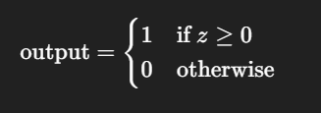

1. **Output:**  
   A single binary value (0 or 1) indicating the predicted class.